431440
(code number)

Cordon-4 Electromagnetic Field Analyzer

Operation Manual
4341408-17206450-2018

Moscow
Content
1 Product Description………………………………………………………………4
1.1 Purpose ……………………………………………………………………...4
1.2 Technical Characteristics……………………………………………………5
1.3. In Box ………………………………………………………………………5
1.4 Operating the Product ……………………………………………………….6
1.4.1 Controls and connectors ………………………………………………..6
1.4.2 Operating modes ……………………………………………………….8
1.4.3 Field Indicator Mode …………………………………………………...8
1.4.4 Spectrum Analyzer Mode ……………………………………………..10
1.4.5 Identifiers Mode ………………………………………………………13
1.5 Power Supply ………………………………………………………………14
1.6 Marking ……………………………………………………………………14
1.7 Package …………………………………………………………………….14
2 Product Intended Use …………………………………………………………..15
2.1 Operational Limitations…………………………………………………….15
2.2 Getting Started ……………………………………………………………..15
2.3 Operating in Search Mode …………………………………………………15
3 Maintenance ……………………………………………………………………17
4 Storage ………………………………………………………………………….17
5 Transportation …………………………………………………………………..17
6 Disposal ………………………………………………………………………...18

This operation manual (hereinafter referred to as OP) is related to the Cordon-4 electromagnetic field analyzer (hereinafter referred to as ' the product'), that is manufactured in accordance with TU 4341408-17206450-2018

OPERATION PRECAUTIONS

WARNING

• Do not expose the product to water, moisture, or dust.
• Do not expose the product to direct sunlight.
• Do not open the product. User service is not supported
• Do not expose the product to the sources of strong electromagnetic fields.
• Do not place the product near radiators or other heaters.
• When operating the product, protect antennas (especially directed ones) against excessive mechanical influences

Read this instruction manual carefully before using the product.

1 Product Description

1.1 Purpose

1.1.1 This is a broadband radio receiver (see Figure 1) intended for searching and locating low power sources of electromagnetic radiation in wide frequency range.
1.1.2. The device can not only detect radiation of secretly installed radio transmitter in the premises given, but also measure its signal frequency and assess power of electromagnetic radiation at the receiving end.
1.1.3. The product is also applied to estimate the change of electromagnetic field according to temporal and spectral field phase diagrams.
1.1.4. The product makes it possible to identify devices of Wi-Fi (2.4 GHz) and Bluetooth standards. The operation of the devices of the remaining wireless communication standards can be observed in the corresponding frequency bands using built-in spectrum analyzer.
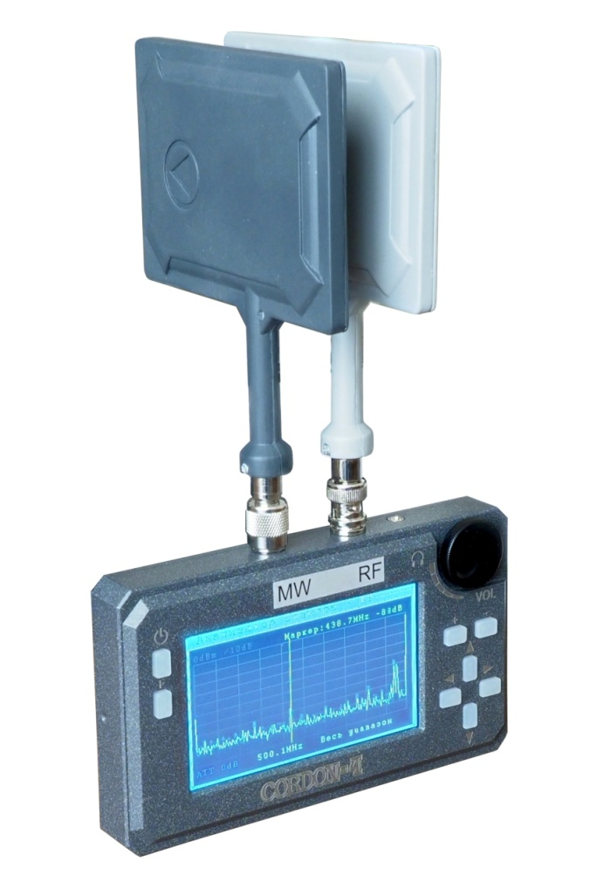
Figure 1. Cordon-4 electromagnetic field analyzer

1.2 Technical Characteristics
1.2.1. Main product specifications are given in Table 1.
Table 1.
Operating frequency range, MHz (divided into two sub bands)  Sub band RF, MHz  Sub band MW, MHz | 0,1÷12000  0,1 ÷ 920  300 ÷ 12000
Dynamic range, dB, at least:  - 0,1÷920 MHz  - 300 ÷12000 MHz | 70  55
Input sensitivity, mV, at least:  - 0,1÷920 MHz  - 920 ÷ 10000 MHz  - 10000 ÷12000 MHz | 0,30  1,25  5,00
Built-in attenuator, dB: | 0; 10; 20; 30
Supply voltage from rechargeable battery, V | 7,2 – 8,4
Current consumption, W | 8, up to
Dimensions without antenna, mm | 165х106х43
Weight of the main block without antennas, kg | 0,64
Operating temperature range, ^{о}С | + 5 ÷ + 40
The manufacturer reserves the right to make changes in the design and construction of the product, which does not degrade the parameters and technical characteristics of the product.
1.2.2 The product does not contain precious materials.
1.3 In Box
1.3.1 Product delivery set is specified in Table 2
Table 2.
Item | Pcs
Cordon-4 field analyzer | 1
Whip antenna of the range 0,1 ÷ 920 MHz | 1
Whip antenna of the range 300 ÷ 12000 MHz | 1
Directional antenna of the range 75÷1000 MHz | Optional
Directional antenna of the range 1000 ÷ 12000 MHz | Optional
Headphones | 1
Charger | 1
Operation Manual | 1
Passport | 1
Transport package | 1
* - The range of directional antennas can be changed upon customer's request.

1.4 Operating the Product
1.4.1 Controls and Connectors
1.4.1 The following controls are on the front panel of the product
(see Figure 2):
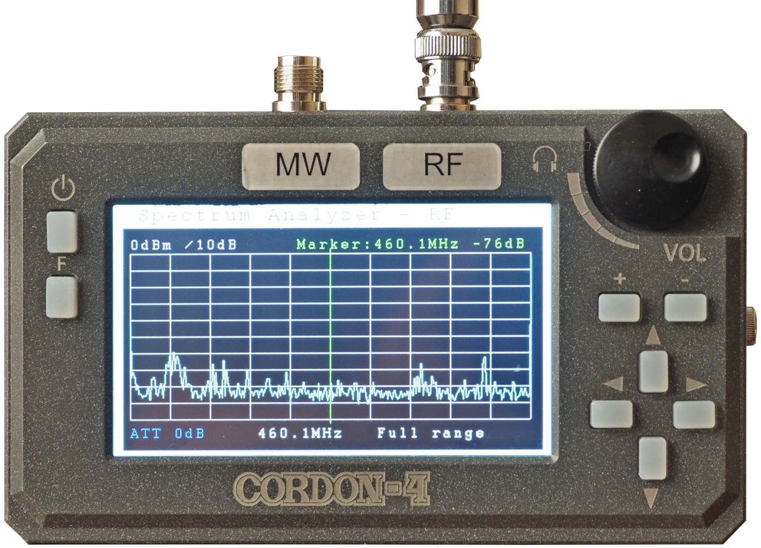
Figure 2 - Front panel of the product.
- button to turn the product on and off; go back to Main Menu;
- F - multifunction button (see Operating Modes);
- + - attenuator control button;
- - (minus) - multifunction button (see Operating Modes);
- ▲ - Peak search button (setting marker to maximum signal frequency in the displayed band of the range) in Spectrum Analyzer mode;
- ▼ - Marker to center button (moving the marked frequency to the middle) in Spectrum Analyzer mode;
- ► - multifunction button (see Operating Modes);
- ◄ - multifunction button (see Operating Modes);
- Sound signals volume control knob
1.4.1.2 There are two antenna connectors on the upper panel of the product: the one on the left (TNC) to connect antenna of the range 300 ÷ 12000 MHz, and the one on the right (BNC) to connect antenna of the range 0.1 ÷ 920 MHz. There is a headphone jack on the right side of the connectors.

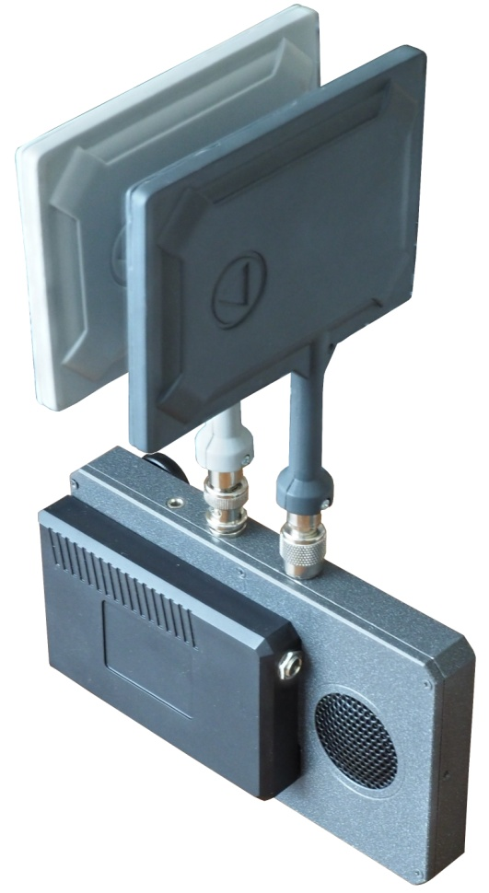
1.4.1.3 There is a rechargeable battery container with a charger connector and a dynamic loudspeaker located on the rear case of the product (see Figure 3).

Figure 3 - Rear view of the product.

1.4.2 Operating Modes

1.4.2.1 The product has three operating modes (see Figure 4):
- Field Indicator;
- Spectrum Analyzer;
- Identifiers.

1.4.2.2 The menu of the product is displayed both in Russian and English. To change language, press the soft key in the upper right corner of the display.

1.4.2.3 Select the mode desired using touch screen.
Mode Selection

Field Indicator

Spectrum Analyzer

Identifiers

Figure 4 - Main Menu - Operating Modes.

1.4.3 Field Indicator Mode
1.4.3.1 Use this mode to identify and locate low-power sources of electromagnetic radiation. The screen of this mode is shown in Figure 5.

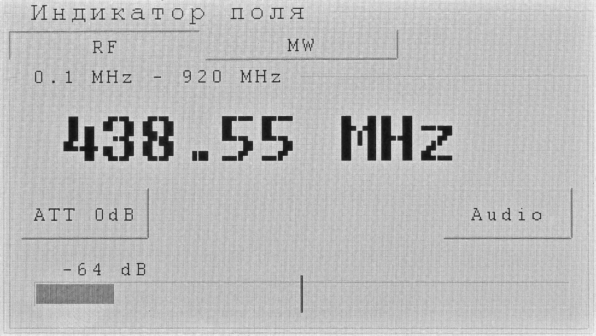
Figure 5 - Screen of Field Indicator mode.
1.4.3.2 At the top of the screen there are subband selection buttons: RF - 0.1 ÷ 920 MHz; MW - 300 ÷ 12000 MHz. Switch subbands using touch screen or the "-" button.
1.4.3.3 On the left below there is the ATT ... dB attenuator control button. Change values using the "+" button, or by directly pressing the ATT ... dB button.
1.4.3.4 On the right below there is Audio button. This button is used to enable Acoustic Feedback Mode. The mode is activated by pressing this button. In this mode, search for radiation sources will be terminated.
1.4.3.5 There is a signal frequency value with maximum level in the activated subband that are displayed in the middle of the screen.
1.4.3.6 At the bottom of the screen there is a ruler to graphically display signal level. There is an option to set threshold, which value access will be accompanied by sound signals. To set threshold use ◄ and ► buttons. To slightly move threshold line, press ◄ or ► button once or several times. To quickly move threshold line, press and hold ◄ or ► button.
1.4.3.7 To exit the mode briefly press the button.

1.4.4 Spectrum Analyzer Mode
1.4.4.1 This mode is intended for analyzing spectrum of detected signals. The screen of this mode is shown in Figure 6.
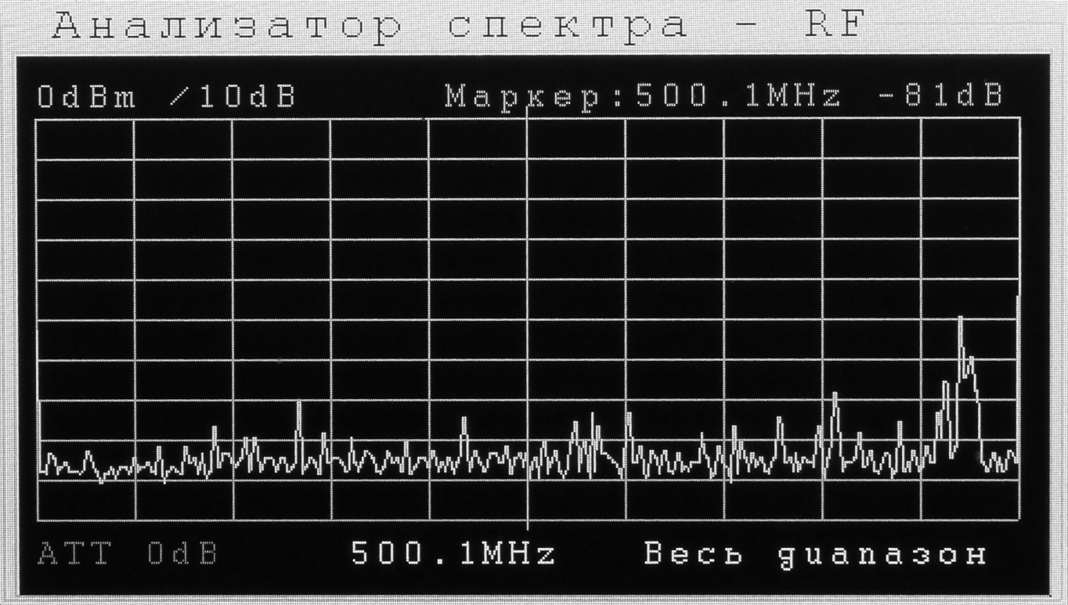
Figure 6 - Screen of Spectrum Analyzer mode.
1.4.4.2 The spectrogram of the selected range is displayed on the screen. The upper line shows the following values:
- maximum displayed level of received signals;
- vertical scale division;
- frequency at the marker point;
- signal level at the marker point.
The lower line of the screen displays the following information:
- attenuation at the antenna input of the product;
- medium frequency of the displayed
range selection;
- width of the displayed range selection.

1.4.4.3 In this mode, hardware buttons perform the following functions:
- F - input (output) to spectrum analyzer adjustment mode;
- "+" - setting attenuator values;
- "-" - subband switching (MW and RF);
- ▲ - Peak Search (setting the marker to maximum signal frequency in the displayed band of the range);
- ▼ - Marker to center (moving the marked frequency to the middle, except for the case of displaying the full range);
- ◄ and ►- moving the marker to the left (right). Briefly press the button for minor movements. To quickly move the marker over the range, press and hold one of the buttons.
1.4.4.4 To enter spectrum analyzer configuration, press the F button. The screen shown in Figure 7 will appear.
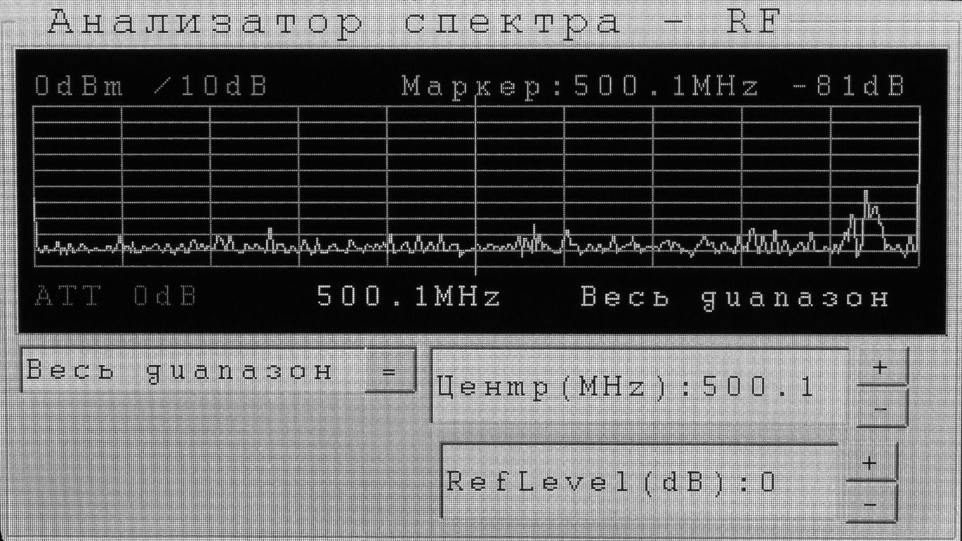
Figure 7 - Setup screen of Spectrum Analyzer mode.
1.4.4.5. At the bottom left, there is a drop-down menu to select width of the displayed range section (20; 50; 100; 200; 500 MHz and full range). To configure this, set the required value, and then press the drop-down menu button

1.4.4.6 The desired range can be selected by setting medium frequency value (for any band except for Full Range). To do this, use either soft buttons in the Medium (MHz) field (move medium frequency halfway of the width of the displayed range section) or press the Medium (MHz) field to open medium frequency configuration window (see Figure 8).
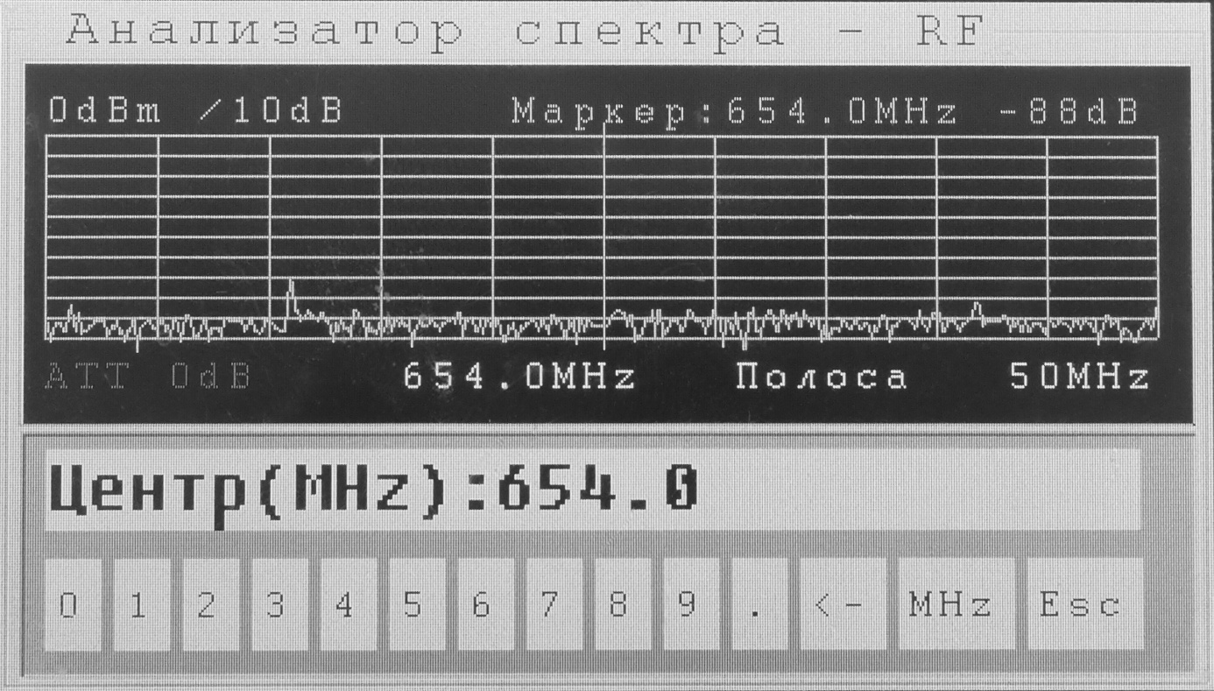
Figure 8 - Spectrum Analyzer screen with medium frequency configuration window.
1.4.4.7 Digital keys are used to set medium frequency. The rest of the buttons are used as follows:
- erasing previous or mistakenly entered values;
-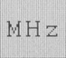 - confirming entered value of medium frequency;
- - exit medium frequency configuration mode without saving.
1.4.4.8 Medium frequency can also be set in the following way (for any value of the band, excluding Full Range): touch the required point (spectrum) on the spectrogram. The marker will move to this point. A more accurate marker value can be set with the ◄ and ► buttons. Then press the ▼ (marker to the middle) button, while the marker moves to the middle, and its frequency becomes medium.
1.4.4.9 The RefLevel (dB): ... window (see Figure 7) is intended to set reference level of spectrum analyzer.
1.4.5 Identifiers Mode
1.4.5.1 This mode is used to detect and identify wireless devices operating in 2.4GHz Wi-Fi and Bluetooth standards.
1.4.5.2 The following information is displayed on the screen in the Wi-Fi source search mode (see Figure 9):
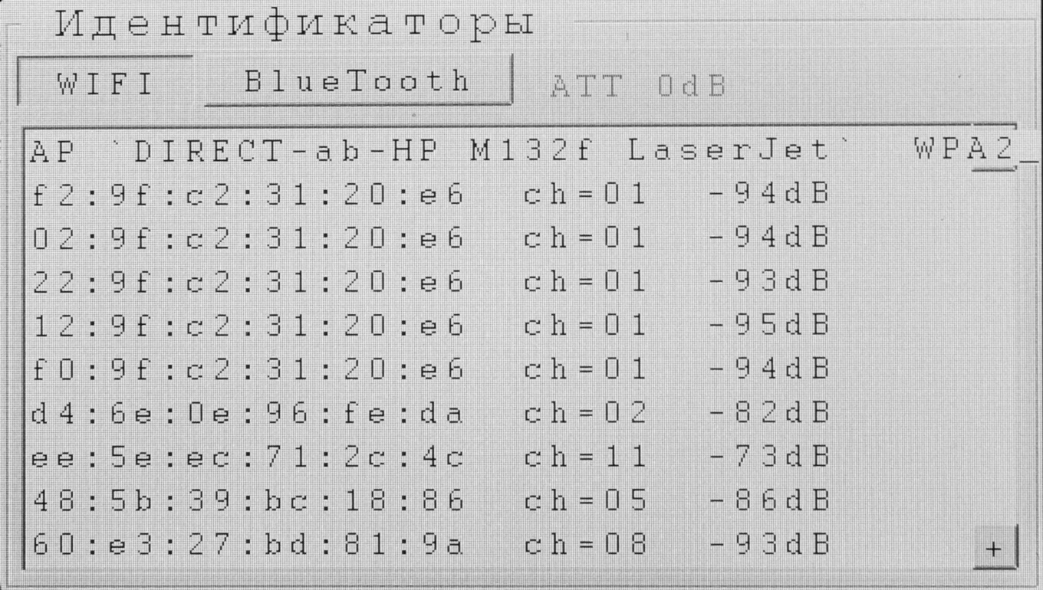
Figure 9 - Screen of Identifiers Mode, search for Wi-Fi sources.
- Wi-Fi access points - name of the access point, encryption type, signal level;
- Wi-Fi clients - MAC address, channel number, signal strength.
1.4.5.3 The following information is displayed on the screen in the Bluetooth source search mode:
- MAC address and signal strength.
1.4.5.3 Use an attenuator to select nearby Wi-Fi or Bluetooth devices. To configure the attenuator use hardware button "+".

1.5 Power Supply
1.5.1 The product is powered by a Li-Pol rechargeable battery with a DC voltage of 7.2 V. The battery capacity is 4500 mAh. Full charging time with the product off takes 3.5 hours.
1.5.2 The product can operate with a charger connected, but in this case charging time increases significantly.
1.5.3 Use only a regular charger to charge the rechargeable battery.

1.6 Marking
1.6.1 The name of the product, CORDON-4, is marked on the front panel of the product below (see Figure 2). On the back of the product case there is an information plate that contains the following information:
- logo and name of the manufacturer;
- product name;
- specification number;
- power consumption parameters;
- serial number;
- date of manufacture.

1.7 Package
1.7.1 The delivery set is packed in a plastic sealed case with a size of 275x220x90 mm, which is placed in a cardboard box measuring 280x225x100 mm.

2 Product Intended Use
2.1 Operational limitations
2.1.1 Do not operate the product outside specified temperature range (see Table 1).
2.1.2 Do not switch on the product immediately after transportation or storage at low temperatures. Keep the product at room temperature for 3 hours.

2.2 Getting Started
2.2.1 Charge the rechargeable battery using battery charger supplied.
2.2.2 Install the antennas. It is possible to use any small antennas within the product's frequency range with corresponding connectors and a resistance of 50 Ohm.
2.2.3 Switch the product on by pressing the button. The product is ready to start operating.

2.3 Operating in Search Mode
2.3.1 Enable the product, enter the Field Indicator mode and select RF or MW subband. Use the ◄ and ► buttons to set threshold, slightly above average interference level. Adjust audio signal volume.
2.3.2 To control input attenuators, use the "+" button, which cyclically switches attenuation values: 0, -10 dB, -20 dB, -30 dB.
2.3.3 Search for means of information retrieval in the room under control. To do this, slowly move the product near the possible location of the eavesdropping equipment: furniture elements, various household items, enclosing room structures, electrical installation equipment, etc.
When getting closer to the source of electromagnetic radiation, the frequency of clicks increases!
When detecting suspicious signals (increasing the frequency of clicks), perform their localization.
2.3.4 If necessary, during search activities use the headphones included in the delivery set by connecting them to the connector.
2.3.5 To analyze spectrum of the signal detected, use Spectrum Analyzer mode.
2.3.6 Information on sources of radiation of Wi-Fi 2.4 GHz or Bluetooth standards can be obtained in the Identifiers Mode.
2.3.7 To switch the product to the Acoustic Feedback mode, press the Audio button (see Figure 5). Set the volume knob to maximum volume level. Search for means of information retrieval. This mode can be used only to search for embedded devices that emit signals with AM and FM modulation.

3 Maintenance
3.1 The product does not require any maintenance, except for periodic cleaning of the housing and display from dust and dirt.
3.2 Use a soft, dry or slightly damp wiping rag to clean the case. To clean the display, use products specifically designed for this purpose.
3.3 During cleaning of the case and display, the product must be switched off and disconnected from the charger.

4 Storage
4.1 The product must be stored in a warehouse heated room in accordance with GOST B9.003 - 80.
4.2 Storage conditions:
1) ambient temperature from + 5 ° С to + 50 ° С;
2) relative humidity of 80% at a temperature of + 30 ° C;
3) atmospheric pressure from 630 to 800 mm Hg. p.
4) absence of vapors of acids, alkalis and aggressive premises in the room.

5 Transportation
5.1. Transportation of the product must be carried out in transport packaging by any mode of transport (aviation - in sealed compartments), provided that it is protected from the effects of atmospheric precipitation. When transporting, prevent the product from falling and sudden strokes, resulting in mechanical damage.
5.2 Transport conditions with regard to the effect of climatic factors must comply with storage conditions in an open area in accordance with GOST B9.003-80. In terms of the impact of mechanical factors, these must comply with GOST V20.57.310 - 98 in medium conditions.

6 Disposal
6.1 The product does not pose a threat to life, health of people or the environment after the end of its service life and does not require special disposal measures.
6.2 The product is disposed by means of dismantling and disassembling.
6.3. Battery pack disposal is accomplished in accordance with local regulations.

